 | Stay on top of your health! | (insert logo)
A message from the
American Society for Gastrointestinal Endoscopy and your doctor
----------------------------------------------------------------------------------------------

General Information About Polyps and Follow-up Colonoscopy
The following information is intended to provide basic information about polyps and
general recommendations on follow-up exams. Check with your doctor about the specific results from your recent colonoscopy and a recommended date for your follow-up exam.

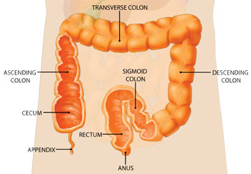

- There are several different types of polyps, which are growths in the lining of the colon. If a polyp was removed during your colonoscopy, you will receive a report indicating the type of polyp you had removed.
- One type of polyp – called an adenomatous polyp (or adenoma for short) – is a benign precancerous growth which may develop into colon cancer in the future if not removed.
- Removal of an adenomatous polyp prevents that polyp from becoming cancerous, but you are still at risk to develop new polyps in your colon. Close follow-up is recommended.
- Over the age of 50, approximately 25% of men and 15% of women will have an adenomatous polyp found on a colonoscopy.
- The presence of a polyp only means that you are at risk for colon cancer. It DOES NOT mean that you will get cancer, however, continued follow-up with your doctor is important to minimize the risk of developing colon cancer in the future.
- If you have a family history of colon cancer, the interval for your follow-up exam may be shortened.
-more-

- Ask your doctor if he or she sends screening reminders when it is time for another colonoscopy. If not, take care to note the date of your next exam so that you stay on schedule with your preventative care.

TALK TO YOUR FAMILY MEMBERS

- Because adenomatous polyps and colon cancer run in families, it is extremely important that you notify your parents, children and siblings if you have a polyp or cancer discovered during your colonoscopy.

  - Your family members should speak with their doctors about having a screening colonoscopy.
  - It is important that they indicate the type of polyp or cancer found during your exam AND your age at time of diagnosis.

    - If you have had an adenomatous polyp removed in the past and change doctors, make sure that your new doctor knows about the polyp history to determine an appropriate screening schedule.

Notes from doctor’s visit or phone call:

________________________________________________________________________

________________________________________________________________________

________________________________________________________________________

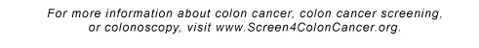
Doctor’s Contact Information:

Name: ___________________________________

Address: _________________________________

Phone: __________________________________

